**Report on Women’s Safety Awareness Program**

**Date of the programme**: 8th March, 2019.

**Organized By:** Nari Sansad of Chakdaha College

**Objective:** To educate students with the knowledge and skills they need for self

defence

**Outcomes:**

1. Participants experienced an increase in self-confidence and self-assurance as they learn effective self-defence techniques.
2. Acquired practical self-defence skills and strategies to respond effectively to various threatening situations, increasing their ability to protect themselves.
3. Increased awareness of their surroundings and potential risks, enabling them to recognize and avoid potentially unsafe situations.

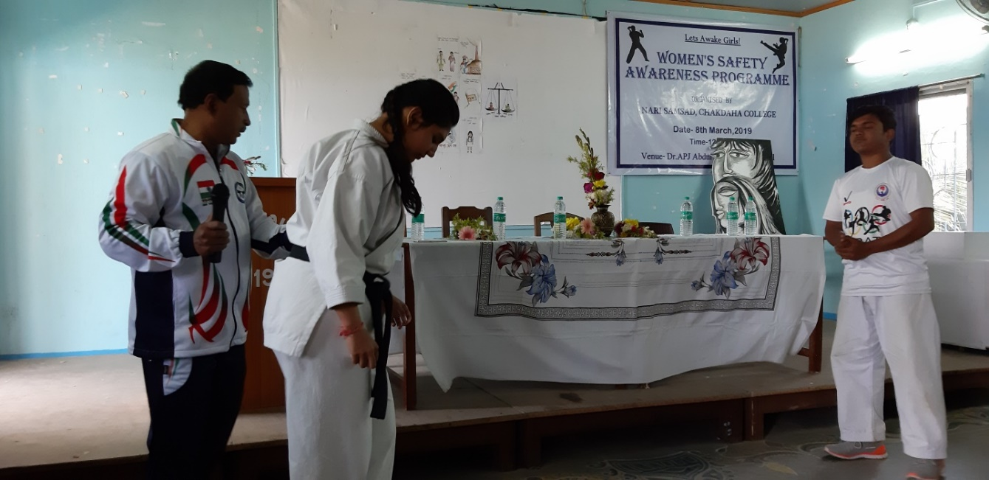

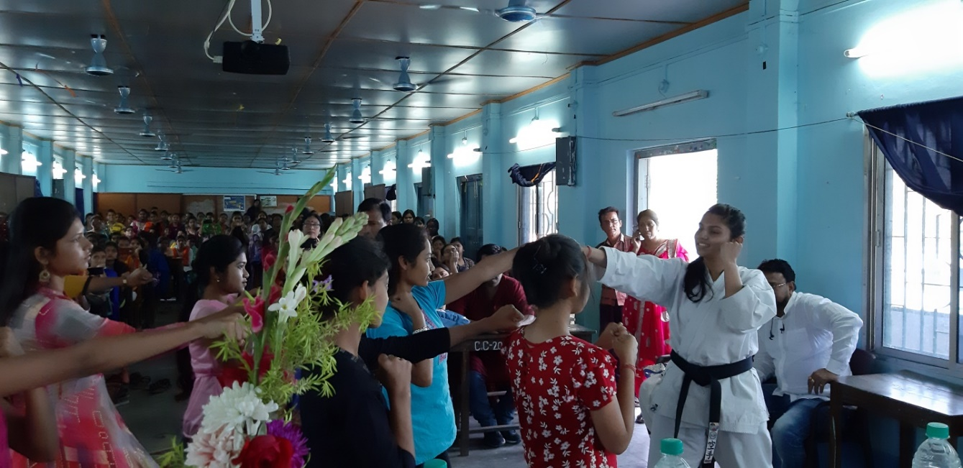

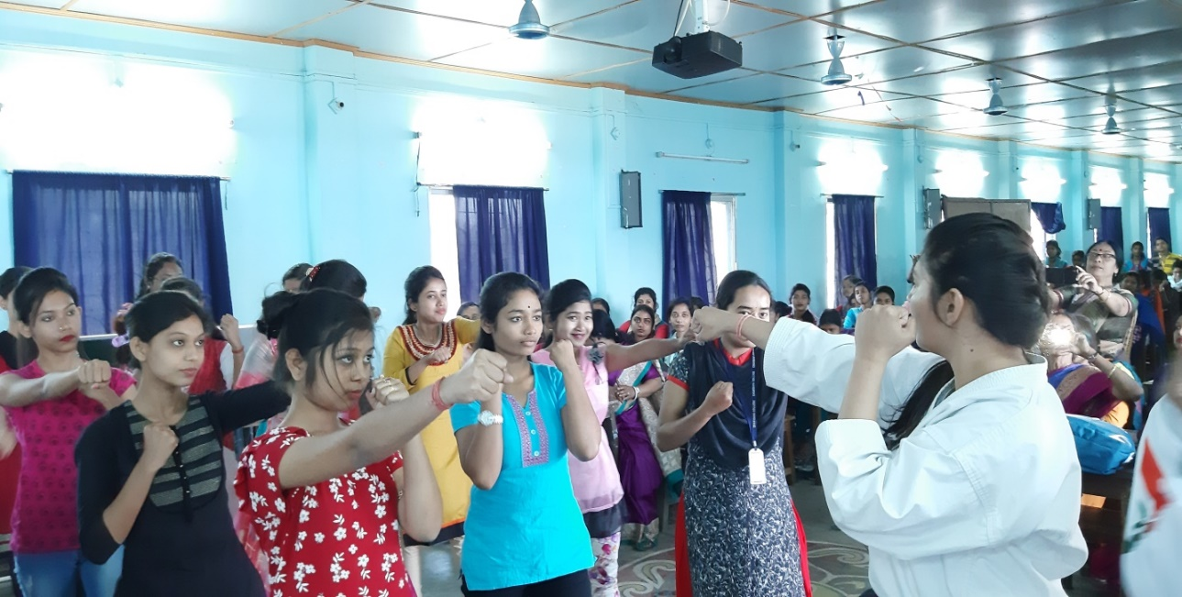

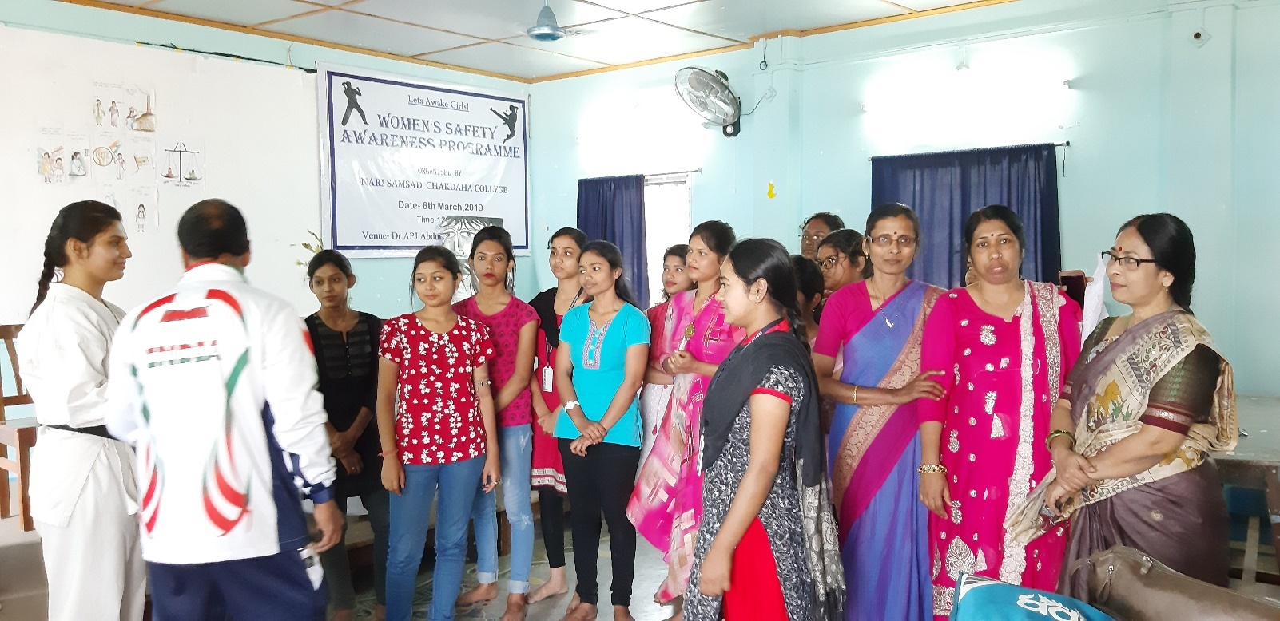

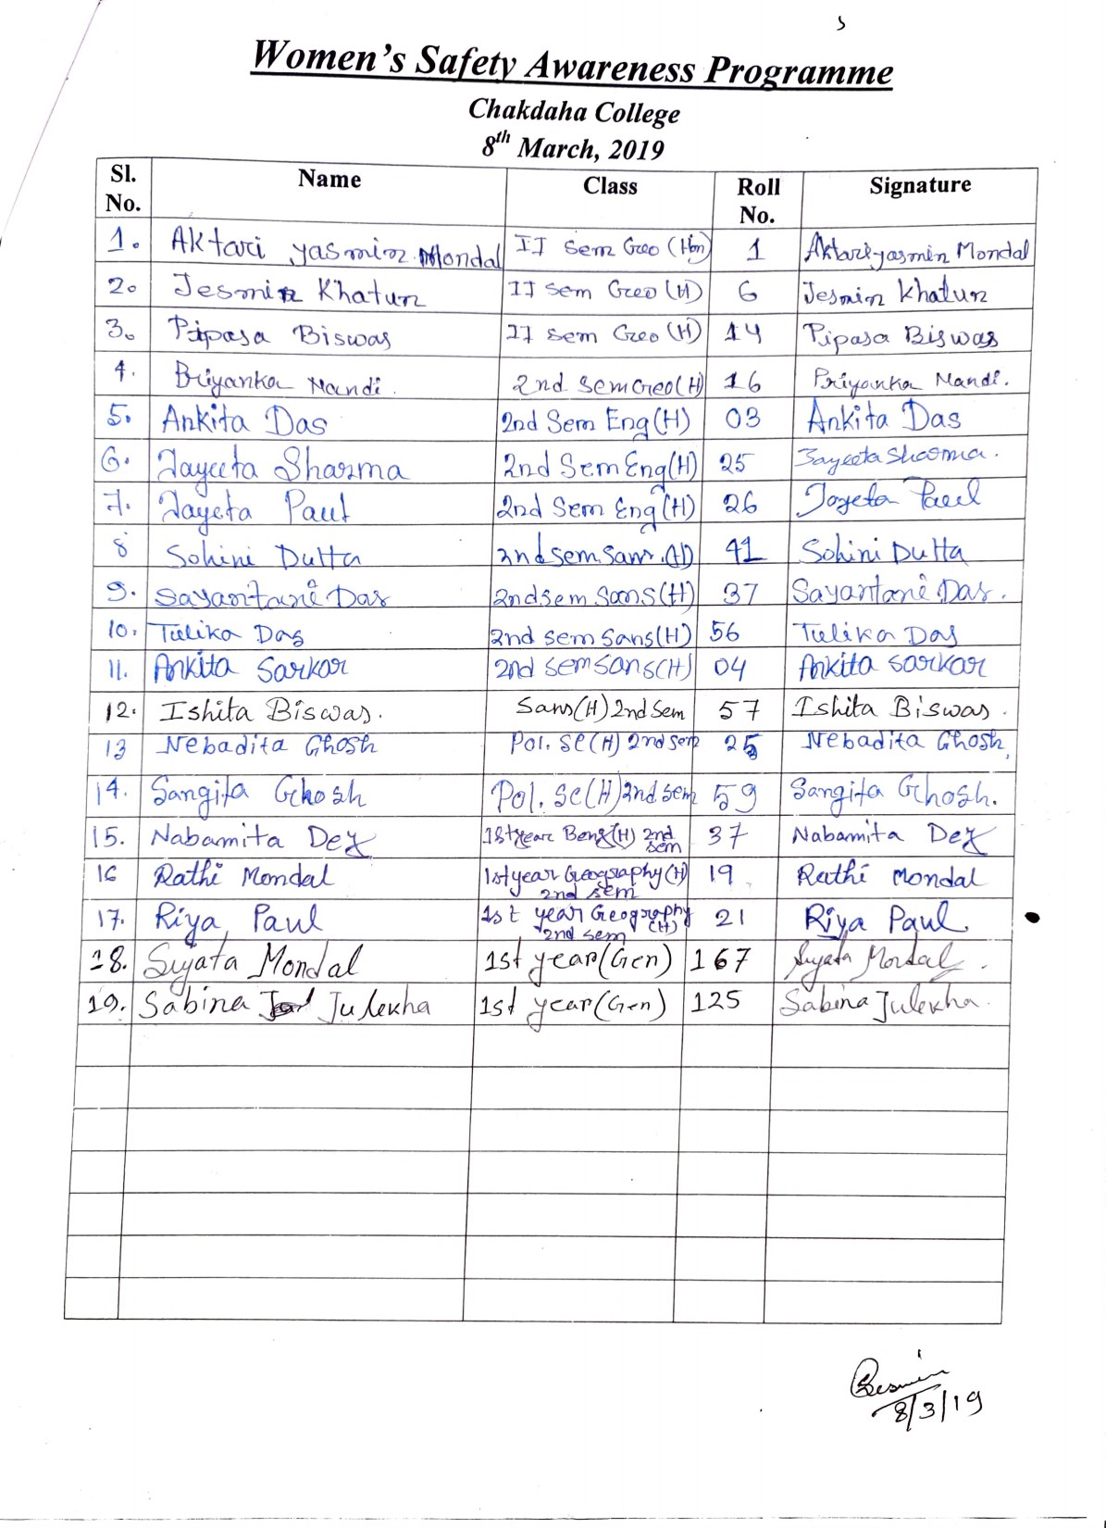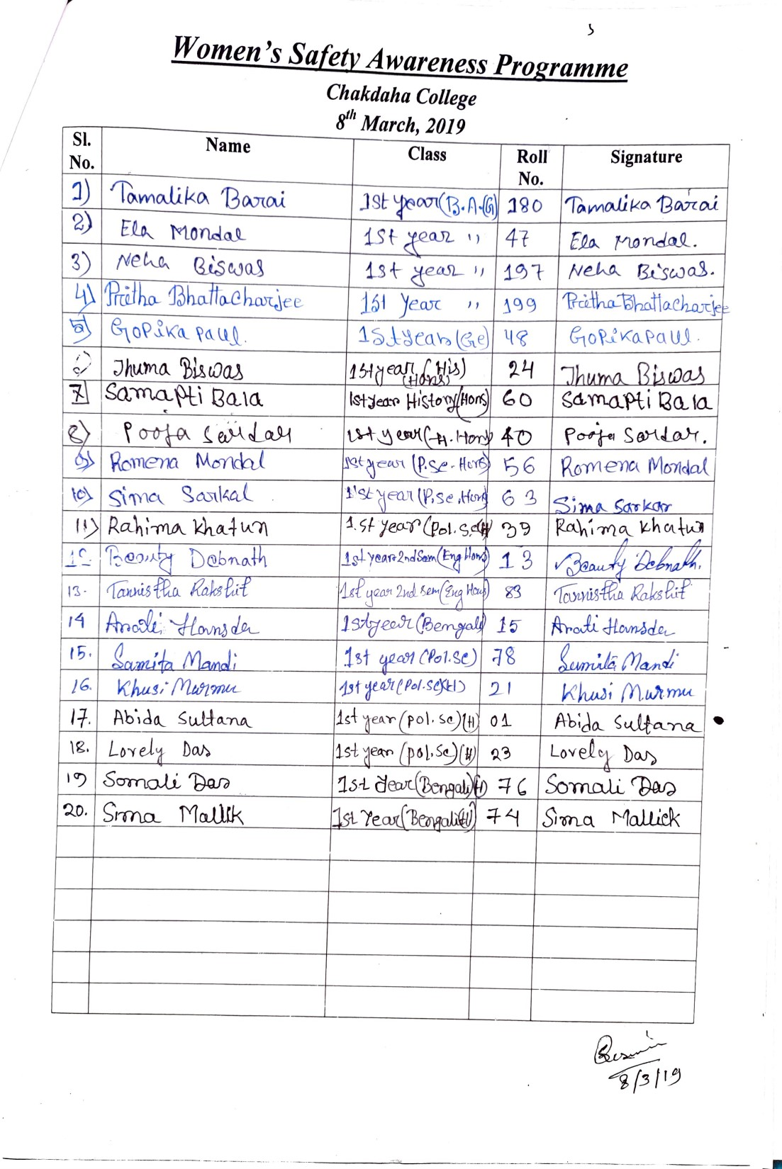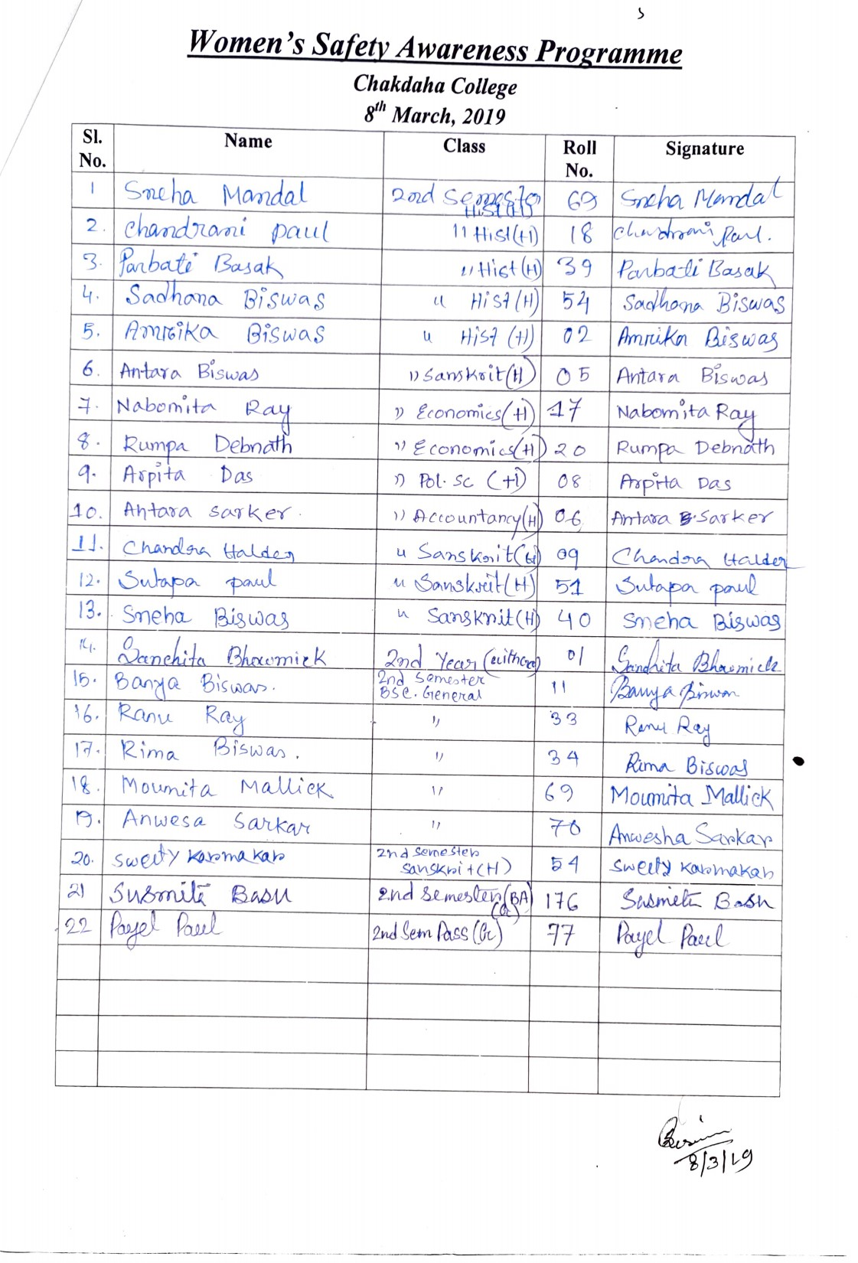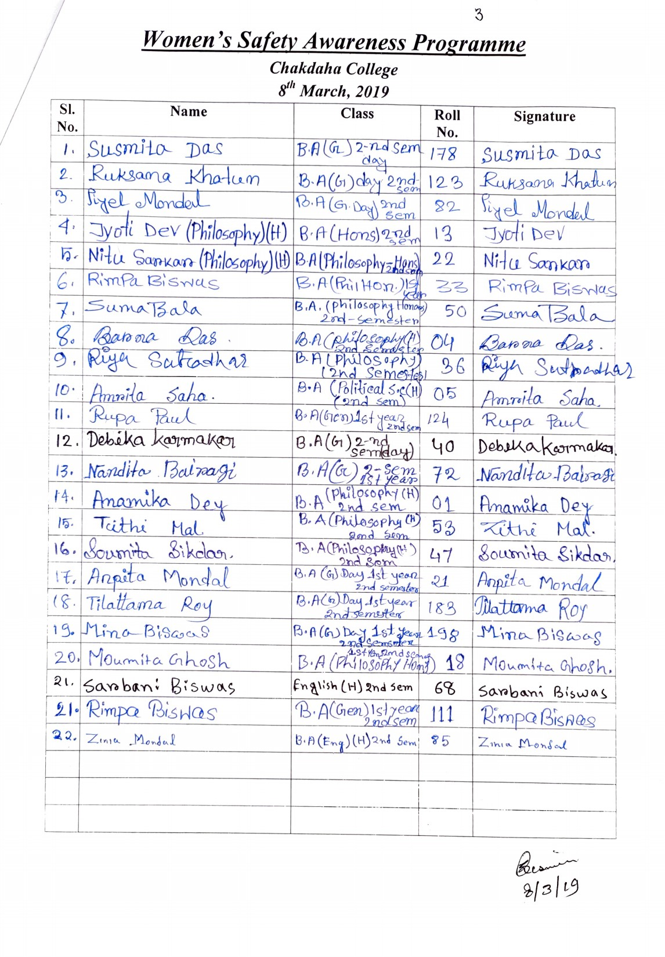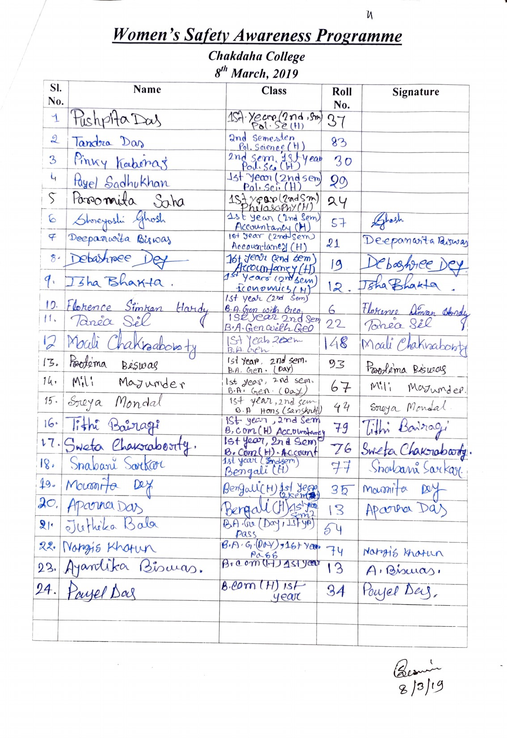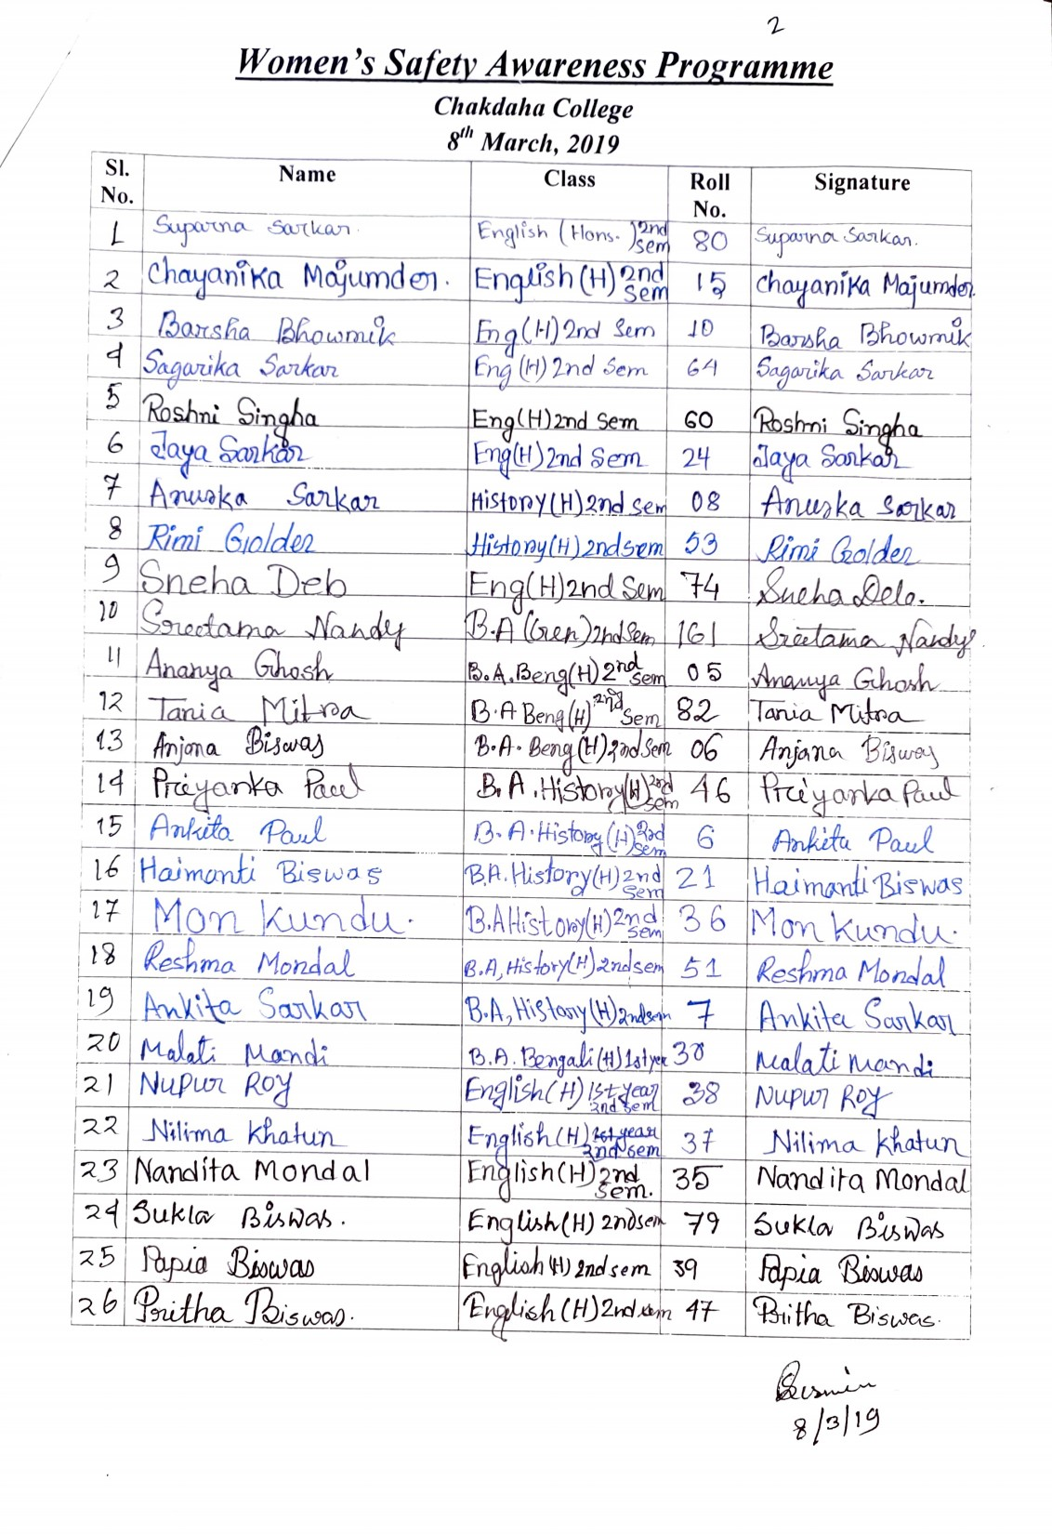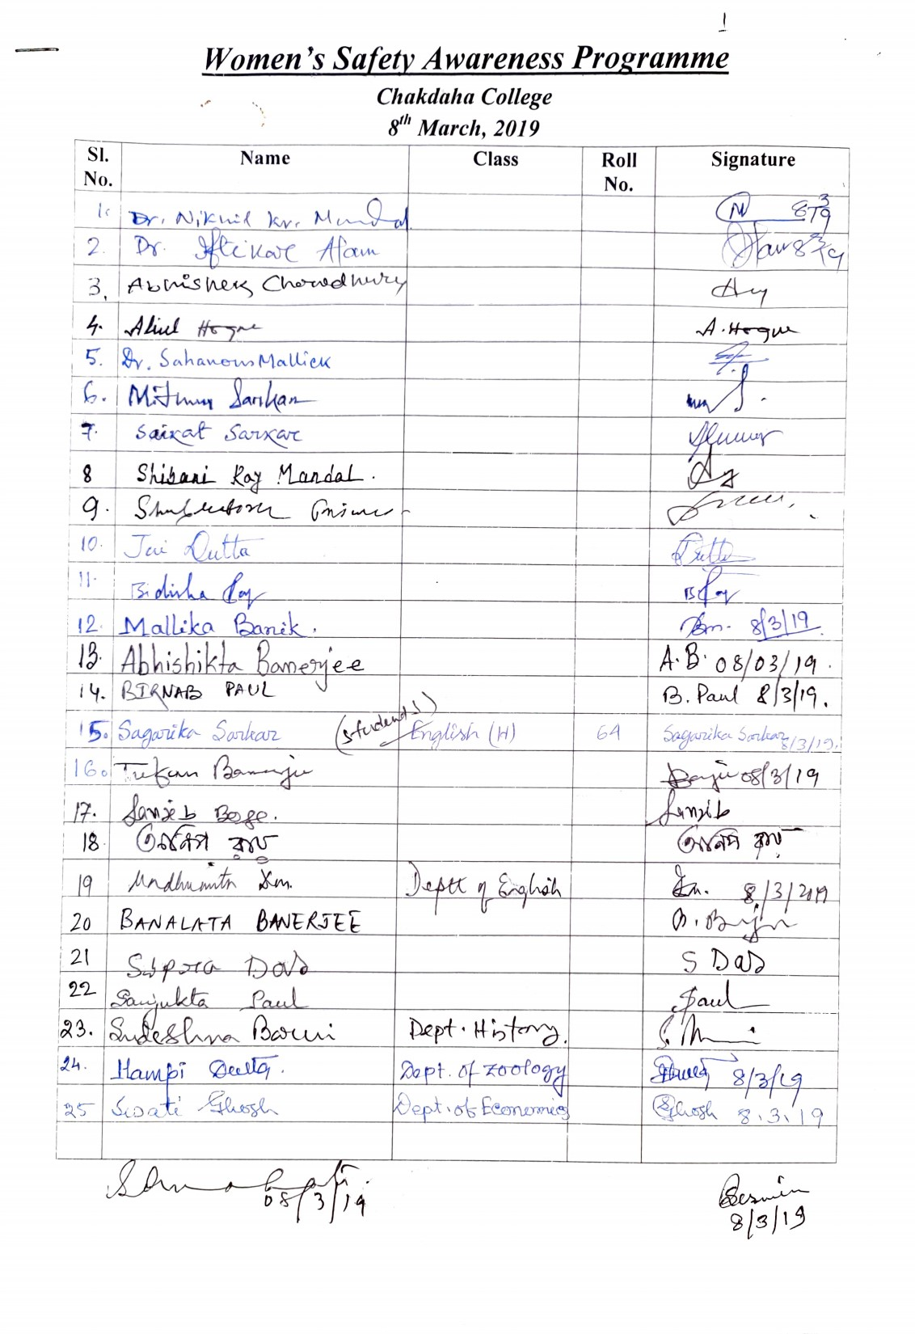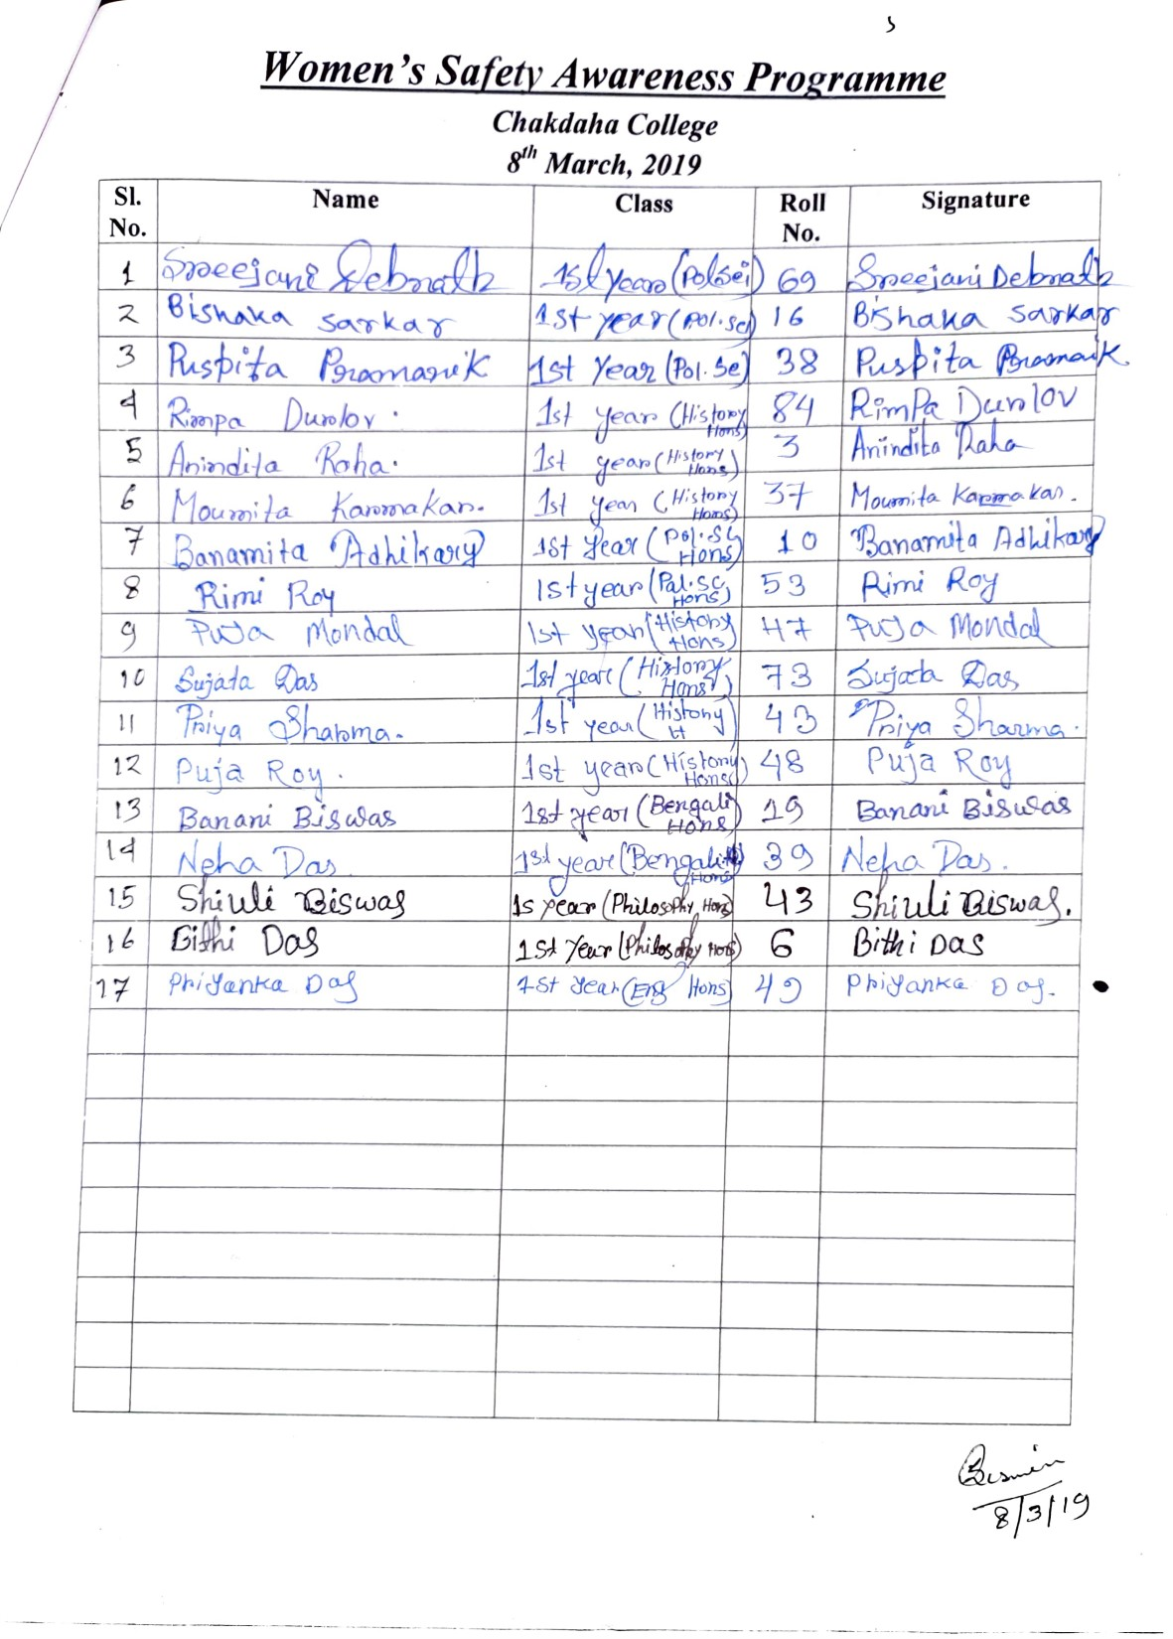

Attendance of the students’ participants